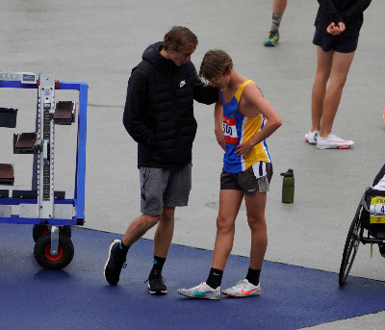

**Coach Profile**

Drew’s philosophy to middle distance is balance and commitment to the events, whilst being mindful to not overtrain at a young age. He is a strong advocate of the coach and athlete relationship. He brings his own personal success, in middle distance running, to his coaching. Albeit only coaching for just over 2 years, he has already been awarded the **Sport NSW Young Coach of the Year Award**. He currently coaches his own high school aged squad of 12 kids, who attend schools around Sydney. Last year, 3 of ‘his’ boys qualified for nationals, where one of them successfully placed third in the U16 Boys 800m.

**Personal Achievements**

My PB’s over each distance:

800m: 1:53.46

1500m: 3:46.28

One Mile: 4:10.21

3000m: 8:09.01

5000m: 14:14.40

10,000m: 30:01

**2011- current:** represented NSW at the Australian Championships, every year

**2018:** represented Australia in the School Sport Australia Cross Country team, which was raced in Paris at the ISF World Schools XC Championships.

**2020:** ran 8:09.01, third fastest time in the world for a Junior, over 3000m (that year), giving him a 12th all-time fastest junior in NSW over 3000m.

**2021:** 2nd @ the Zatopek De Castella 3000m Championships.

**2021:** 2nd @ NSW State Championships, in the Open Mens’ 1500m.

Drew hopes to break 8minutes for 3km, 14minutes for 5km and 29:30 for 10km. He also aims to try to qualify for the World Uni Games next year.

He works casual hours at the Runners Shop in Randwick and part time at Cranbrook School as their XC and MD coach. He attends UTS full time, and graduates next year with a Business degree, majoring in IT and Management.